LINUX BASIC COMMANDS
Ls commands :
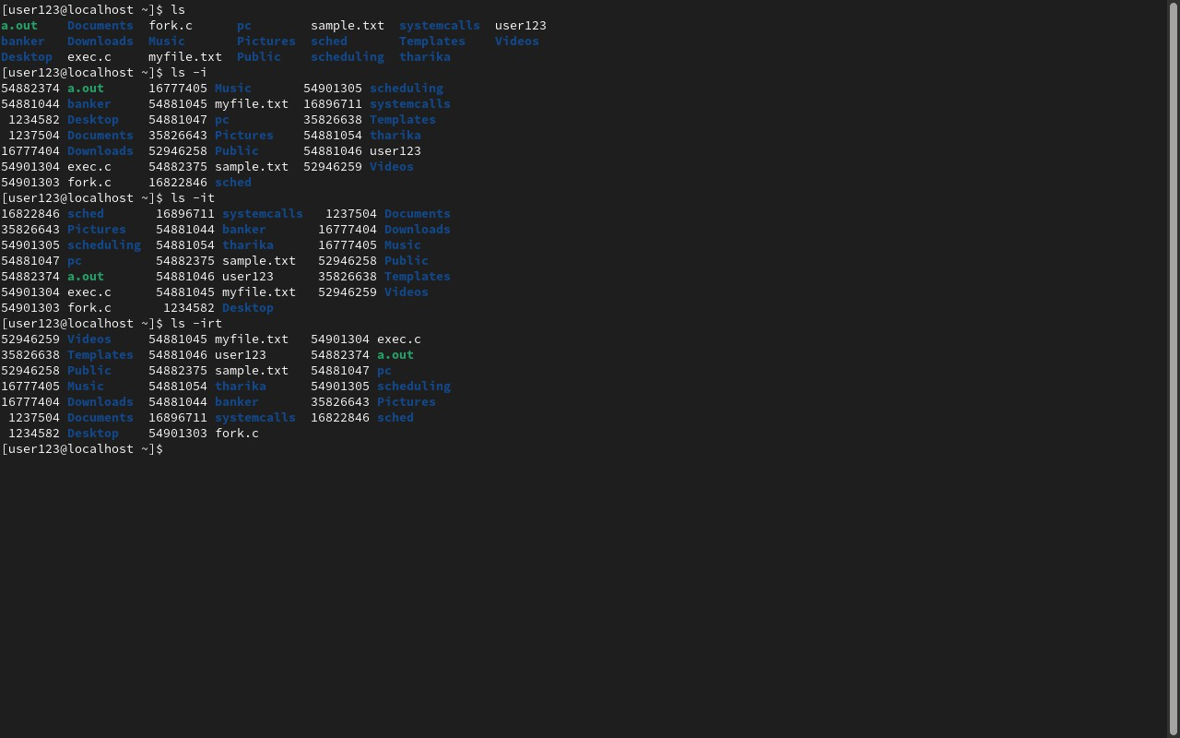
Vi,pwd,touch,cat commands:
